Introduction Programming

Draw A Helicopter
It's just a little something to help establish a blueprint before we start laying down the lines.
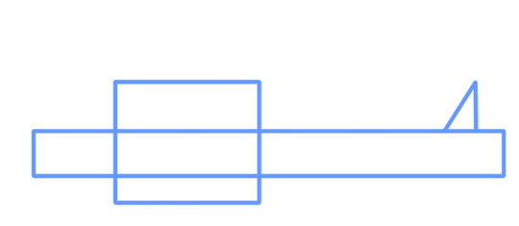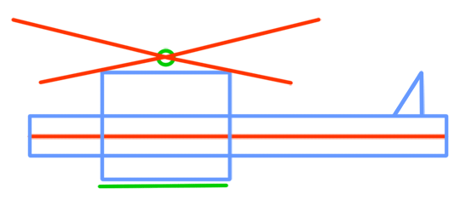
An idea... take a look at some photos of real helicopters. You can get lots of great ideas in this way for establishing that unique look.
To the board...

Second Step - How to Draw a Cartoon Helicopter
Sequence in mind - this is how I decided to best present the steps by which you MIGHT want to draw yours. I say 'might' - as always... it's good to be searching out different ways to the approach. This one works though! :-)
Here goes...
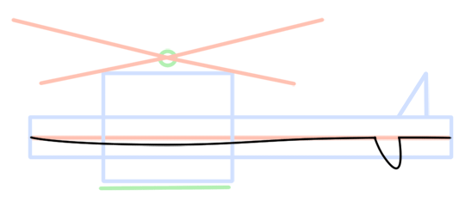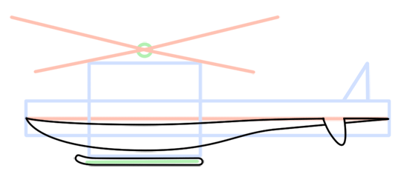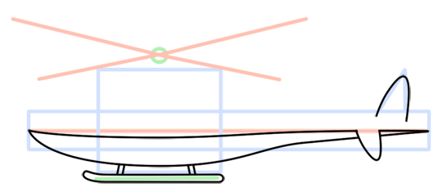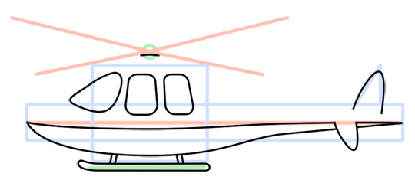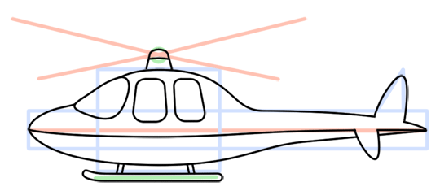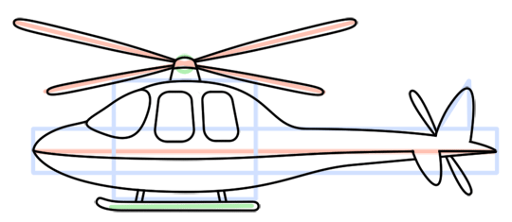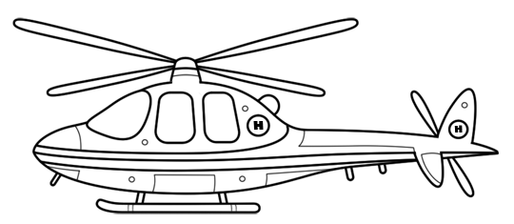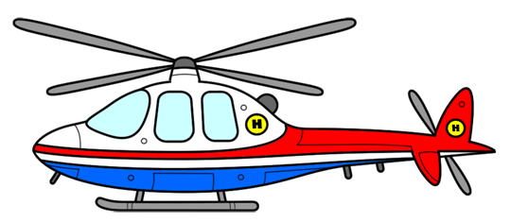
All the little lines at the end - giving off the intricate details of our helicopter... really help to make your cartoon unique in your own way. And you can be random about it too... just let go... add some doors, nuts, bolts, a logo... more or less windows... bigger propellers... yup - have fun.

